**Curriculum Vitae**

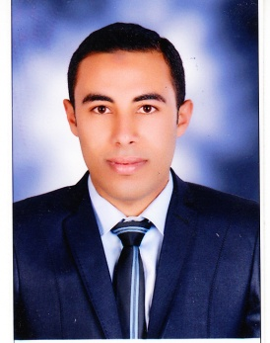**Moustafa Mohammed Moawad**

**Department of Theriogenology**

**Faculty of Veterinary Medicine**

**Assuit University**

1. Personal data:

Moawad Moustafa Mohammed

**Last Name First Name MiddleName**

01063482216

**Mobile Phone**

**Permanent Address:** Department of Theriogenology, Faculty of Veterinary Medicine, Assuit University.

**Citizenship:** Egyptian.

**Place of Birth:** Byla, Kafr El-Shiekh. **Date of Birth:** 10/10/1991.

**Marital Status: Military service:** Exempted.

**E-Mail address:** shasha_vet@yahoo.com

1. **Colleges and Universities Attended (in a chronological order):**

|  |  |  |  |
| --- | --- | --- | --- |
| University/School | Country | Obtained Degree | Graduation Date |
| Faculty of Veterinary Medicine. Assuit University. | Egypt | B.Sc. of veterinary medicine | 2014 |
| Abo Badwy Secondary School. | Egypt | General secondary certificate | *2009* |
| Abo Badwy Prep. School. | Egypt | Junior high certificate | 2006 |

1. **Employment History:**

|  |  |  |
| --- | --- | --- |
| **Employer** | **Position** | **Inclusive Dates** |
| Assuit University, Faculty of Veterinary Medicine | Demonstrator | November 18, 2014 |

1. **Languages and computer skills:**

|  |  |  |  |
| --- | --- | --- | --- |
| Arabic | Speaking mother tongue | Readingexcellent | Writingexcellent |
| English | Speakingexcellent | Readingexcellent | Writingexcellent |
| France | Speakingfairly good | Readingfairly good | Writingfairly good |
| Computer Skills | Good | Microsoft Office (Excel, Power Point, Word, Access). | Photo Shop CS, Flash MX, Internet. |

1. **Conferences, Training courses and Workshops:**
2. Participation with poster presentation in the First Annual Student Research Conference of Assuit Veterinary Student’s Scientific Association, Assiut University, Egypt.
3. Participation as member of Student care Assuit Veterinary Student’s Scientific Association, Assiut University, Egypt.
4. **Teaching ,Scientific and applied activities :**
5. Sharing in treatment of obstetrics cases in the veterinary teaching hospital, Faculty of Vet. Medicine, Assuit University.
6. Sharing in Diagnosis and Treatment Convoys in Assuit, which organized by Faculty of Veterinary Medicine, Assuit University.
7. Participation in the teaching programs (practical part) for the students of third, fourth and fifth levels, Faculty of Veterinary Medicine, Assuit University.
8. A membership of veterinary extension center, Faculty of Veterinary Medicine,Assuit University.
9. Participation in summer practical training of final year’s students, Faculty of Veterinary Medicine, Assuit University.